Truncated icosahedron

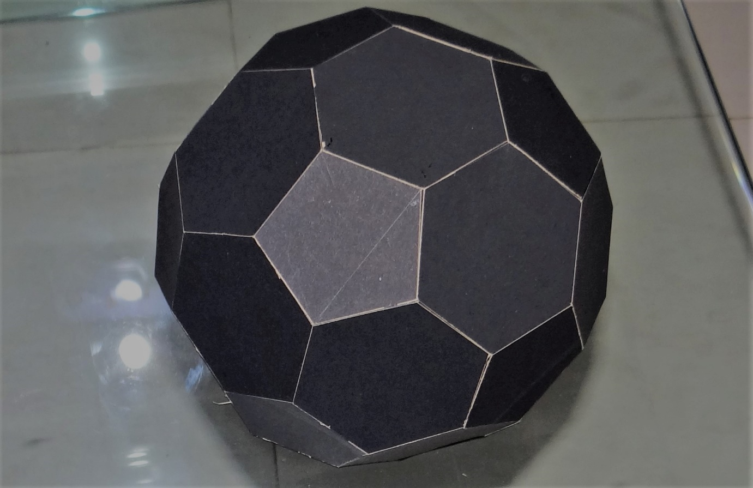

Team Members:

1. Arya Rajiv
2. Umashankar
3. Jayadev M
4. Aditya S